Minimum Spanning Tree

What is a Spanning Tree?
Given an undirected and connected graph G={V,E}, a spanning tree of the graph G is a tree that spans G (that is, it includes every vertex of G) and is a subgraph of G(every edge in the tree belongs to G)

What is a Minimum Spanning Tree?
The cost of the spanning tree is the sum of the weights of all the edges in the tree. There can be many spanning trees. Minimum spanning tree is the spanning tree where the cost is minimum among all the spanning trees. There also can be many minimum spanning trees.
Minimum spanning tree has direct application in the design of networks. It is used in algorithms approximating the travelling salesman problem, multi-terminal minimum cut problem and minimum-cost weighted perfect matching. Other practical applications are:
- Cluster Analysis
- Handwriting recognition
- Image segmentation
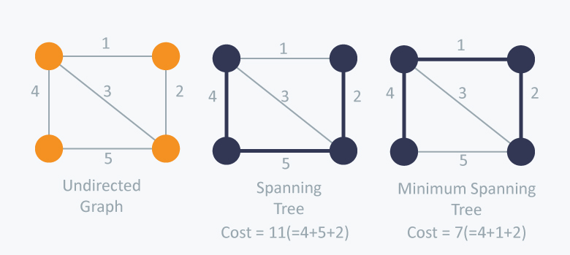
There are two famous algorithms for finding the Minimum Spanning Tree:
- Prim’s Algorithm
- Kruskal’s Algorithm

Prim’s Algorithm
Prim’s Algorithm, use Greedy approach to find the minimum spanning tree. In Prim’s Algorithm we grow the spanning tree from a starting position
Algorithm Steps:
- Maintain two disjoint sets of vertices. One containing vertices that are in the growing spanning tree and other that are not in the growing spanning tree.
- Select the cheapest vertex that is connected to the growing spanning tree and is not in the growing spanning tree and add it into the growing spanning tree. This can be done using Priority Queues. Insert the vertices, that are connected to growing spanning tree, into the Priority Queue.
- Check for cycles. To do that, mark the nodes which have been already selected and insert only those nodes in the Priority Queue that are not marked.
Example-1:

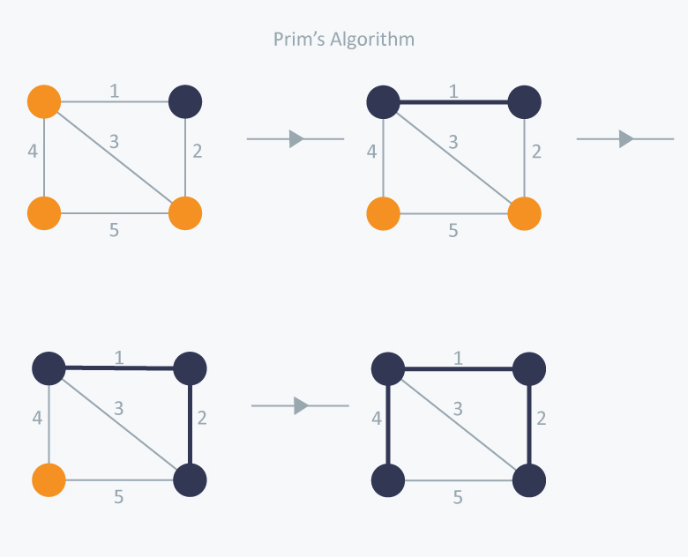

In Prim’s Algorithm, we will start with an arbitrary node (it doesn’t matter which one) and mark it. In each iteration we will mark a new vertex that is adjacent to the one that we have already marked. As a greedy algorithm, Prim’s algorithm will select the cheapest edge and mark the vertex. So we will simply choose the edge with weight 1. In the next iteration we have three options, edges with weight 2, 3 and 4. So, we will select the edge with weight 2 and mark the vertex. Now again we have three options, edges with weight 3, 4 and 5. But we can’t choose edge with weight 3 as it is creating a cycle. So we will select the edge with weight 4 and we end up with the minimum spanning tree of Total cost = 1 + 2 +4 = 7.

Kruskal’s Algorithm
Kruskal’s Algorithm builds the spanning tree by adding edges one by one into a growing spanning tree. Kruskal's algorithm follows greedy approach as in each iteration it finds an edge which has least weight and add it to the growing spanning tree.
Algorithm Steps:
- Sort the graph edges with respect to their weights.
- Start adding edges to the MST from the edge with the smallest weight until the edge of the largest weight.
- Only add edges which doesn't form a cycle , edges which connect only disconnected components.
So now the question is how to check if 2vertices are connected or not ?
Example-2:
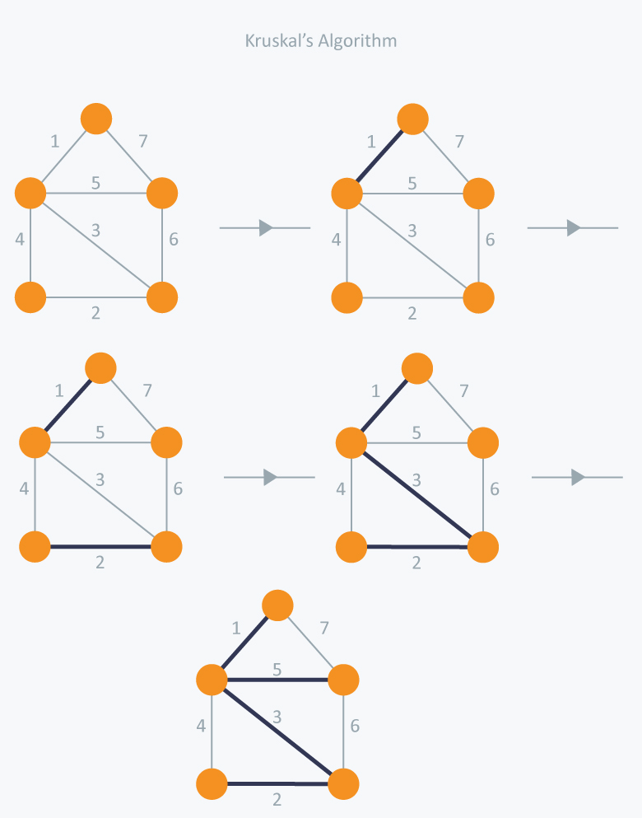
In Kruskal’s algorithm, at each iteration we will select the edge with the lowest weight. So, we will start with the lowest weighted edge first i.e., the edges with weight 1. After that we will select the second lowest weighted edge i.e., edge with weight 2. Notice these two edges are totally disjoint. Now, the next edge will be the third lowest weighted edge i.e., edge with weight 3, which connects the two disjoint pieces of the graph. Now, we are not allowed to pick the edge with weight 4, that will create a cycle and we can’t have any cycles. So we will select the fifth lowest weighted edge i.e., edge with weight 5. Now the other two edges will create cycles so we will ignore them. In the end, we end up with a minimum spanning tree with Total cost 11 = 1 + 2 + 3 + 5 = 11.
Time Complexity:
In Kruskal’s algorithm, most time consuming operation is sorting because the total complexity of the Disjoint-Set operations will be O(V log E), which is the overall Time Complexity of the algorithm.
More Examples:
Prim’s Algorithm: Example-3
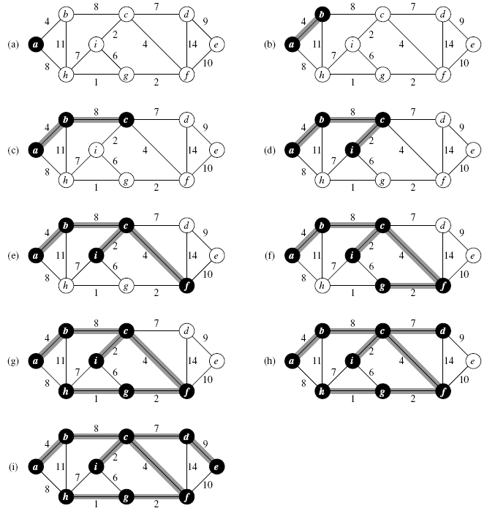

Total Cost of the MST = 4+8+2+4+2+1+7+9 = 37.

Kruskal’s Algorithm: Example-3
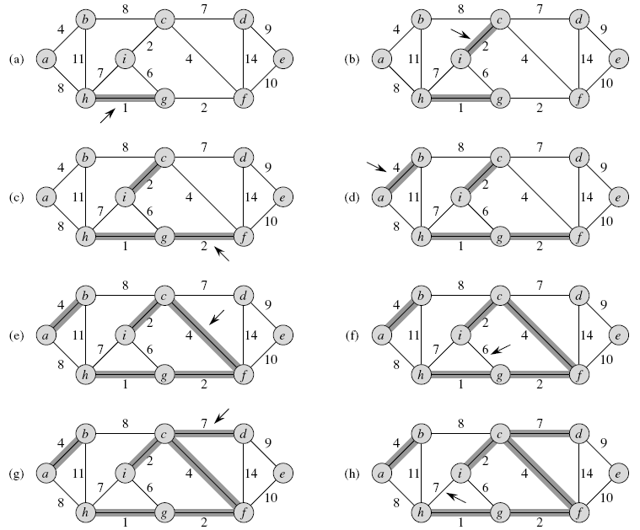
Total Cost of the MST = 1+2+2+4+4 +7 + 9 = 29.
Kruskal’s Algorithm: Example-4
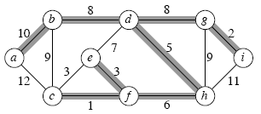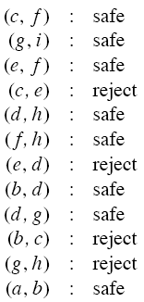
Total Cost of the MST = 1+2+3+5+6+8+8+10+11=54

